john.f.balualua

CSS Activity

Screen Shots:

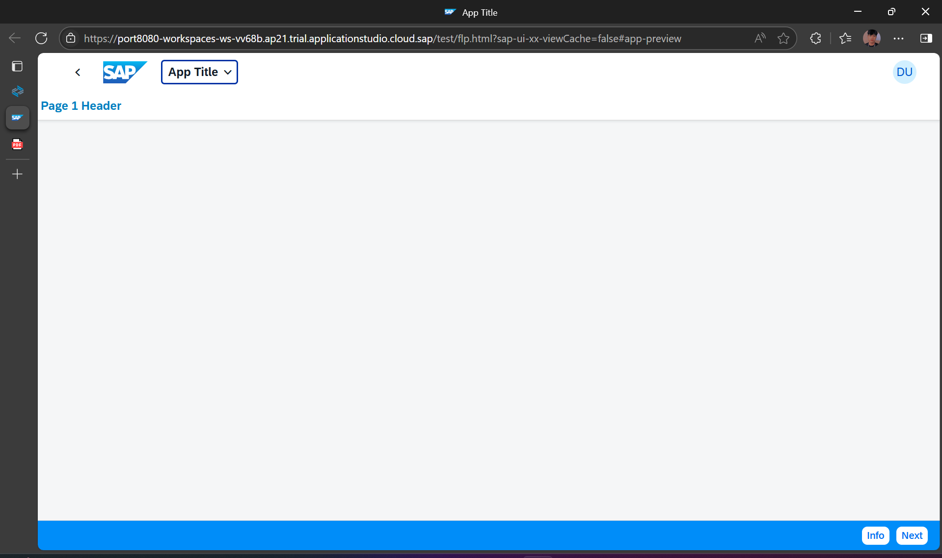

THEME DESIGNER

Screenshots:

